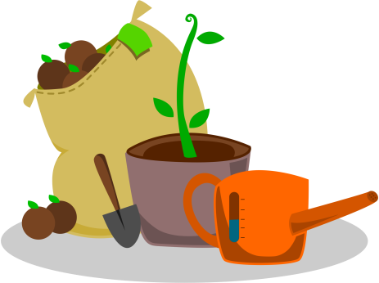

1 Do you work in the garden sometimes?
2 How do you help your parents in the garden?
3 How often do you work in the garden?
4 Are you fond of gardening? Why?
5 What plants do you grow?
6 What can you pick in the garden?
7 What do you grow at school?
8 What are your favourite activities in the garden?
9 How can you take care of flowers?
10 How far is your garden from your home?
11 In what ways can be gardening useful?
12 Can work in the garden be dangerous?
13 Which vegetables do you know?
14 Which kinds of fruit do you know?
15 Which trees and shrubs do you know?
16 Which gardening tools can people use in the garden?
17 What do plants need for living?

