Where are they? How many people are there? What are they wearing? How old are they? What are they doing there? Who are they? What else can you see in the picture? How are they? Why are they there?

Where is she? How many people are there? What is she wearing? How old is she? What is she doing there? Who is she? What else can you see in the picture? How is she? Why is she there?

Where is she? How many people are there? What is she wearing? How old is she? What is she doing there? Who is she? What else can you see in the picture? How is she? Why is she there?
What is the weather like?

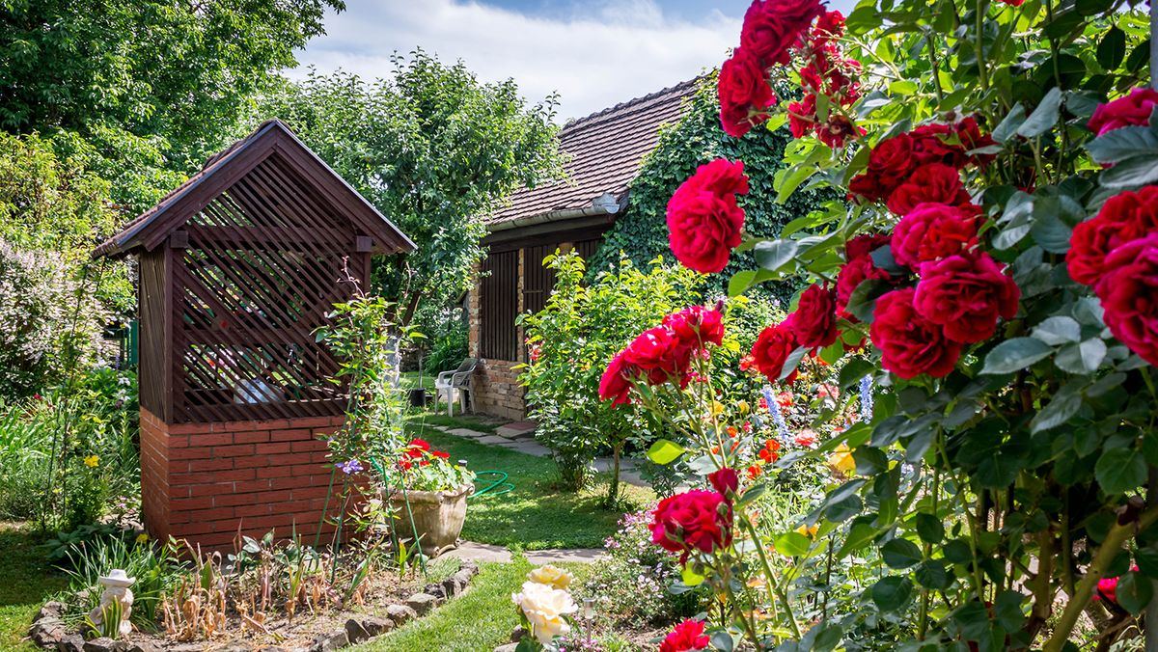
Where are they? How many people are there? What are they wearing? How old are they? What are they doing there? Who are they? What else can you see in the picture? How are they? Why are they there?

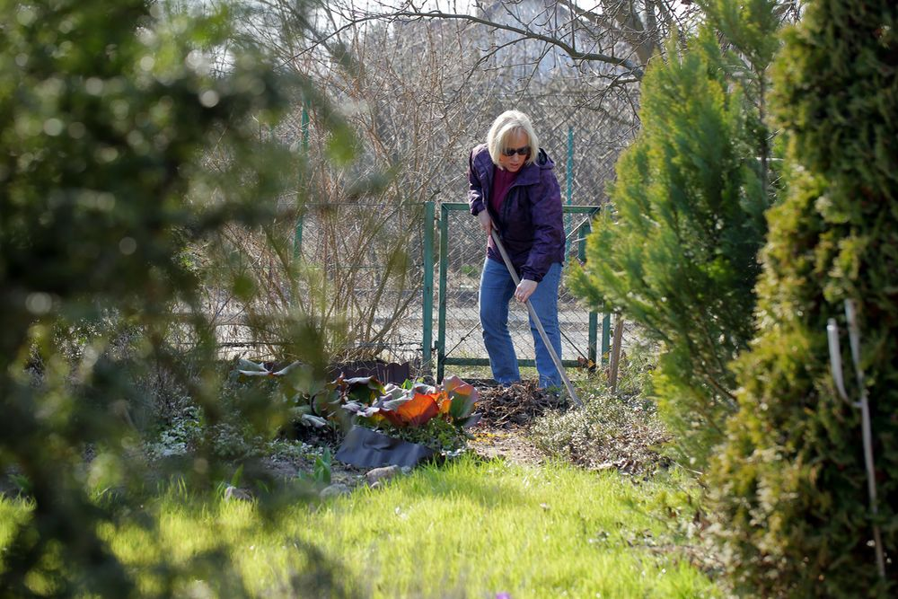Where is she? How many people are there? What is she wearing? How old is she? What is she doing there? Who is she? What else can you see in the picture? How is she? Why is she there?
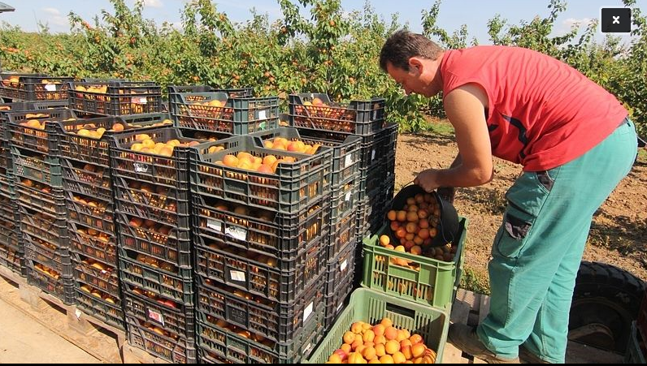
Where is he? How many people are there? What is he wearing? How old is he? What is he doing there? Who is he? What else can you see in the picture? How is he? Why is he there?

